### **WEBSITE NAME:** [**Jiji**](http://jiji.ng) **Nigeria**

### **WEBSITE DESCRIPTION:** Jiji is an e-commerce website, specifically a classifieds marketplace. It facilitates the buying and selling of goods and services between individuals and businesses.

### **URL:** [**Jiji.ng**](http://jiji.ng)

### **STEP-BY-STEP ACTIONS PERFORMED**

* **Homepage Access** – Navigated to jiji.com on desktop and mobile.
* **Account Search** – Searched for “Solar Lights”; applied Location: Rivers State filter.
* **Listing View** – Clicked on a listing; reviewed images, pricing, "Contact seller" UI.
* **Messaging** – Clicked to message seller via web chat form.
* **Post New Ad** – Attempted to post ad; assessed form validation and image upload.
* **Responsiveness** – Emulated mobile (Chrome DevTools) and accessed menus.
* **Security Trust Features** – Checked for “verified seller” tag or ID.
* **Help/Support** – Looked for FAQ/support links in footer or chat.

### **OBSERVED ISSUES**

#### **Bug Reports with Screenshots**

#### **Bug 1**: Page Crashes When Using Browser Navigation Consistently

* **Bug ID**: Bug001
* **Title:** Application crashes after multiple clicks on browser Back/Forward buttons
* **Environment:** 
  + **Browser:** Desktop Chrome v115
  + **OS:** Windows 10
* **Preconditions:** User should be on the Jiji homepage.
* **Steps to Reproduce:**
  + Visit the Jiji homepage.
  + Click on any listing

.

* + Navigate through 3–4 product pages.
  + Click the Back button repeatedly (3+ times), then the Forward button quickly.
* **Expected Result:** Page should navigate between visited pages smoothly without crashing.
* **Actual Result:** The page becomes unresponsive, blank, or crashes entirely.
* **Severity:** High
* **Priority:** Critical
* **Impact on Users:**
  + Causes confusion and disrupts browsing.
  + Users may abandon the session thinking the site is broken.
  + This will reduce user engagement by 80%.
* **Recommended Fix:**
  + Implement Route Guarding with History State Management: Use a client-side routing solution (like: React Router or Angular Router) to manage history changes gracefully.
  + Apply Debounce or Throttle Logic: Prevent rapid repeated clicks on navigation by introducing throttle logic to limit frequency.
  + Preserve Component State: Use componentDidMount and componentWillUnmount (or React Hooks) to properly save/restore component state.
  + Fallback Handling: If state is undefined (e.g., due to stale memory), display a fallback “Reload page” or redirect to home.
  + Conduct Memory Profiling: Use DevTools to monitor memory leaks during navigation and fix uncleaned listeners or large object retention.
* **Screenshots for Bug 001 (Page Crashes When Using Browser Navigation Consistently)**

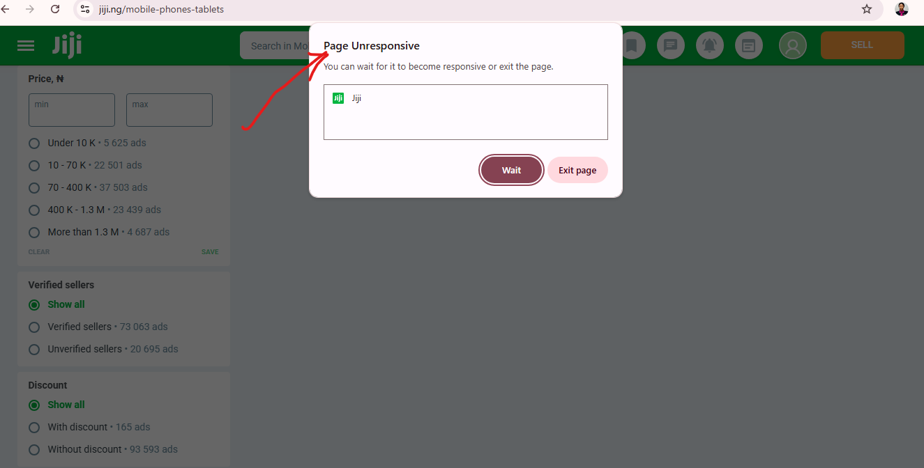

#### 

#### 

#### **Bug 2**: Listing Form Accepts Random Webpage Screenshots as Product Images

* **Bug ID**: Bug002
* **Title:** Image upload allows irrelevant/non-product images without error.
* **Environment:**
  + **Browser:** Desktop Chrome v115
  + **OS:** Windows 10
* **Preconditions:** User is on the product listing page
* **Steps to Reproduce:**
  + Click on the “Sell” button.
  + Start creating a new product listing.
  + Upload a random screenshot (e.g., a web page or unrelated UI screen).
* **Expected Result:** Image validator should flag images that are not product photos (e.g., with no product detected).
* **Actual Result:** Screenshot is accepted and used as the product’s image.
* **Severity:** Medium
* **Priority:** High
* **Impact on Users:**
  + Decreases trustworthiness of the platform.
  + Buyers encounter misleading or irrelevant listings.
* **Recommended Fix:**
  + **Integrate an Image Content Validator:**
* Use AI services like Google Cloud Vision, Amazon Rekognition, or an open-source model (e.g., MobileNet) to detect object presence.
* Only allow images classified with high confidence as containing physical objects or products.
* **Add Image Size & Format Rules:**
* Accept JPEG/PNG only, minimum resolution 600x600px.
* Reject screenshots (e.g., those containing window chrome/UI elements) using edge-detection or layout heuristics.
* **Show Preview and Warning**: Display uploaded image with a notice: “This doesn’t look like a valid product image. Try again.”
* **Screenshot for Bug002 (Image upload allows irrelevant/non-product images without error)**

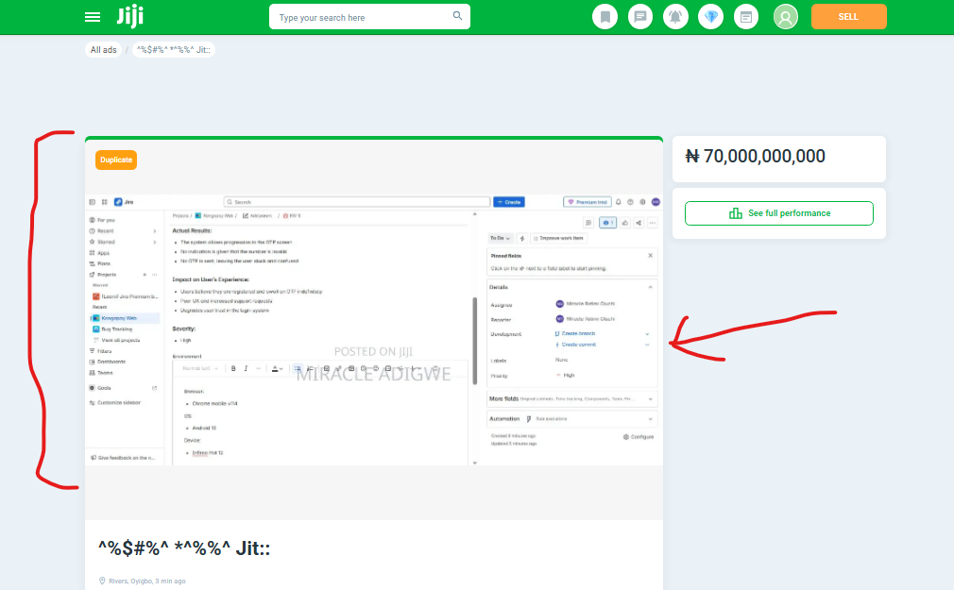

#### **Bug 3**: Listing Form Accepts Characters in the “Product Name Title” Field

* **Bug ID:** Bug003
* **Title:** Product Name/title field accepts special characters with very few letters.
* **Environment:**
  + **Browser:** Desktop Chrome v115
  + **OS:** Windows 10
* **Preconditions:** User is on the Product listing page
* **Steps to Reproduce:**
  + Start a new listing.
  + In the "Title" field, input: @!##&^?$%jhi
* **Expected Result:** Title field should restrict to readable alphanumeric text with limited special characters.
* **Actual Result:** Field accepts and submits arbitrary characters.
* **Severity:** Medium
* **Priority:** Medium
* **Impact on Users:**
  + Search results and listings appear unprofessional to users.
  + Reduces credibility and indexing (SEO).
* **Recommended Fix:**
  + **Use Regex Validation on Input Field:** js  
      
    /^[a-zA-Z0-9\s\-.,]{10,80}$/
    - Accept only alphanumeric characters, hyphens, periods, commas, and space.
    - Set min/max length (e.g., 10–80 characters).
  + **Restrict Emojis & Symbols:**
    - Use a JS emoji filter (emoji-regex) to detect and remove emojis.
  + **Live Input Sanitization:** Show error immediately if disallowed characters are entered: “Only standard letters, numbers, and punctuation allowed.”
* **Screenshot for Bug003 (Listing Form Accepts Characters in the “Product Name Title” Field)**

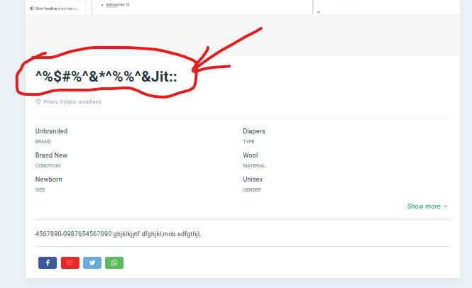

#### **Bug 4**: Description Field Allows Meaningless Content

* **Bug ID:** Bug004
* **Title:** Listing description field permits gibberish or meaningless text without validation.
* **Environment:**
  + **Browser:** Desktop Chrome v115
  + **OS:** Windows 10
* **Preconditions:** User is on product listing page.
* **Steps to Reproduce:**
  + Start a new listing.
  + In the description box, input: asdfghjk lkjhgfd rtyuiop!!
* **Expected Result:** Form should alert users if the description is too short or lacks meaningful words.
* **Actual Result:** Description accepted and posted without warnings.
* **Severity:** Medium
* **Priority:** Medium
* **Impact on Users:**
  + Reduces listing quality and buyer trust.
  + Wastes moderation resources and pollutes search results.
* **Recommended Fix:**
  + **Implement Semantic Validation:**
    - Use a lightweight NLP model or keyword checker to assess content quality.
    - **Reject descriptions with:**
      * Fewer than 5 meaningful words.
      * Repeated characters (e.g., asddffgh, zzzzzz).
      * No recognized nouns or verbs.
  + **Guide Sellers:**
    - Show a prompt: “Describe the item clearly. Include condition, model, usage, etc.”
    - Use placeholder: “e.g., Used iPhone 12, 128GB, working perfectly, no cracks.”
* **Screenshot for Bug004 (Description Field Allows Meaningless Content)**

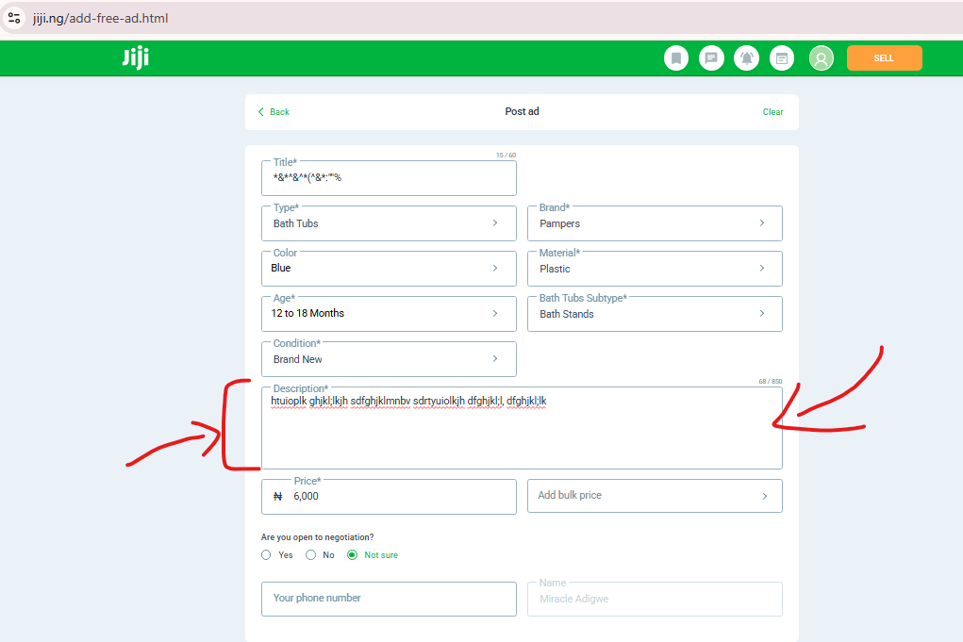

#### 

#### **Bug 5:** Verified Sellers Posting Products Without Any Specification.

* **Bug ID:** Bug005
* **Title:** Someverified seller listings omit key product specifications (e.g., warranty, size, type).
* **Environment:**
  + **Browser:** Desktop Chrome v115
  + **OS:** Windows 10
* **Preconditions:** User is on the Jiji sellers listing page.
* **Steps to Reproduce:**
  + Search for any product by a verified seller (badge visible).
  + Check product listing: key fields like size, type, usage missing.
* **Expected Result:** Verified sellers should be required to fill all product specification fields.
* **Actual Result:** Listings show no detailed specs despite the verified badge.
* **Severity:** High
* **Priority**: Critical
* **Impact on Users:**
  + Creates distrust among buyers expecting higher quality from verified sellers.
  + Lowers conversion rate and increases back-and-forth questioning.
* **Recommended Fix:**
  + **Enforce Mandatory Fields for Verified Sellers:**
* Use conditional logic: If seller.verified == true, make all key specs required (condition, category-specific attributes).
* Show inline validation: “Verified listings must include complete specifications.”
* **Quality Review Process:**
* Flag incomplete listings by verified sellers for manual moderation.
* Allow users to report “Missing product info” via a button.
* **Badge Trust Criteria:**
* Only show a “Verified” badge on listings that meet all data quality benchmarks.
* **Screenshot for Bug005 (Verified Sellers Posting Products Without Any Specification)**

